SJF vs Priority Comparison

Section 1: Assumptions & Rules:

* Priority Definition: We assume a Lower Value = Higher Priority rule. For example, a process with priority 1 is more urgent than a process with priority 5.

* Tie-Breaking Rule: In all algorithms, if two processes have the same priority or the same burst time, the First-Come-First-Served (FCFS) rule is used to resolve the tie based on the Arrival Time.

* Preemption Logic:
- Priority (Preemptive): A running process will be interrupted if a new process with a higher priority arrives.
- SJF (Preemptive): Also known as SRTF, the current process is interrupted if a new process arrives with a shorter remaining burst time.
- SJF (Non-Preemptive): Once a process starts execution, it cannot be interrupted regardless of any new arrivals.

* Time Units: All time-related metrics (Arrival, Burst, WT, TAT, RT) are handled as discrete integer units.

* Input Validation: The system assumes that Process IDs are unique and all numeric inputs for burst and arrival times must be non-negative.

Section 2: Test Scenarios Analysis:

Scenario A: Basic Mixed Workload
- Input Data:
  - P1: Arrival=0, Burst=6, Priority=2
  - P2: Arrival=2, Burst=2, Priority=1
  - P3: Arrival=4, Burst=3, Priority=3
- Description
"This scenario confirms the fundamental logic of the three algorithms. In SJF Non-Preemptive, P1 finishes entirely before P2 starts, whereas in SJF Preemptive, P2 interrupts P1 at time 2 because it is shorter. Meanwhile, Priority scheduling focuses on the priority values regardless of the burst duration."
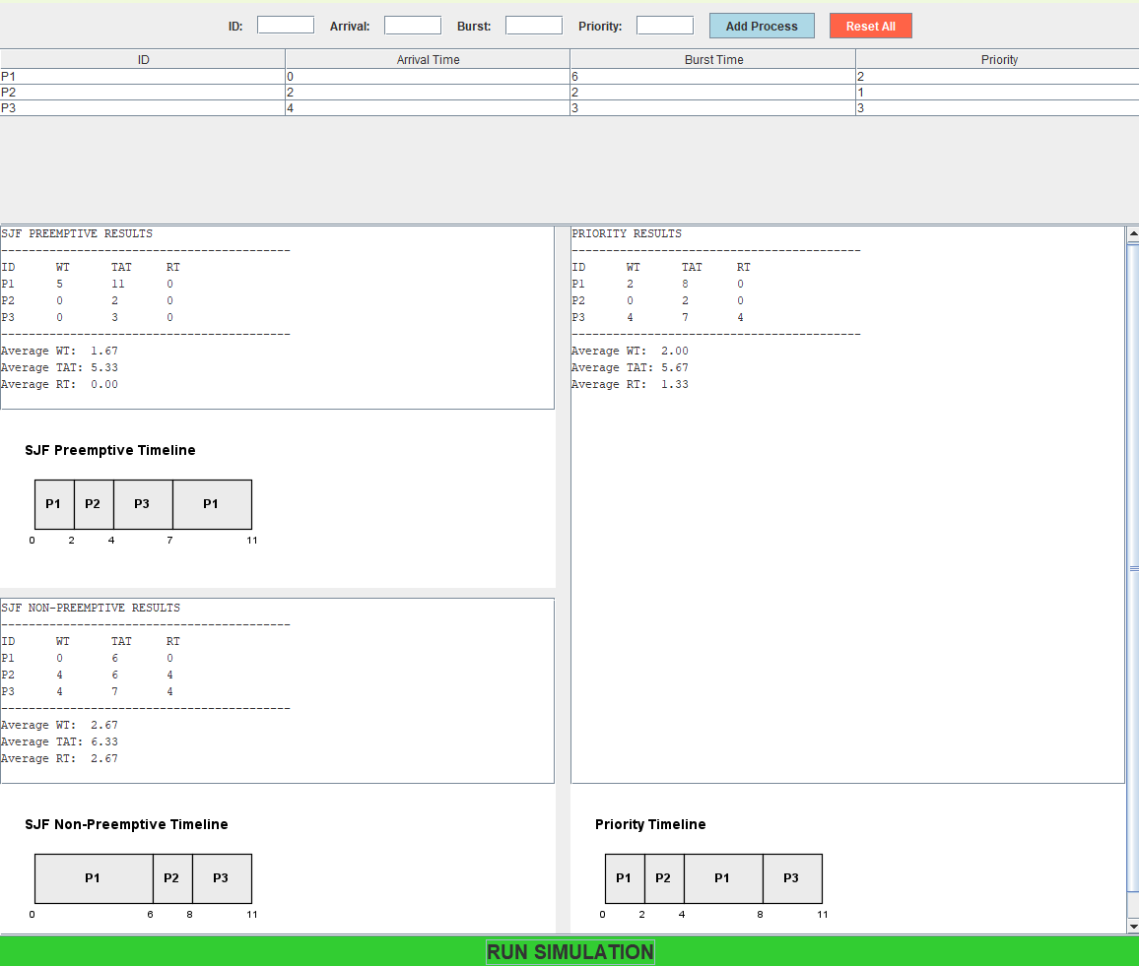

Scenario B: Conflict between Burst Time and Priority
- Input Data:
  - P1: Arrival=0, Burst=8, Priority=1 (Long but Urgent)
  - P2: Arrival=1, Burst=2, Priority=5 (Short but Not Urgent)
- Description
"This test reveals the policy trade-off. Priority scheduling ensures P1 finishes first because it is urgent. However, both SJF versions (Preemptive and Non-Preemptive) prefer P2 to minimize waiting time. The difference here is that SJF Preemptive will stop P1 immediately at time 1 to run P2, while Non-Preemptive will make P2 wait until P1 finishes at time 8."
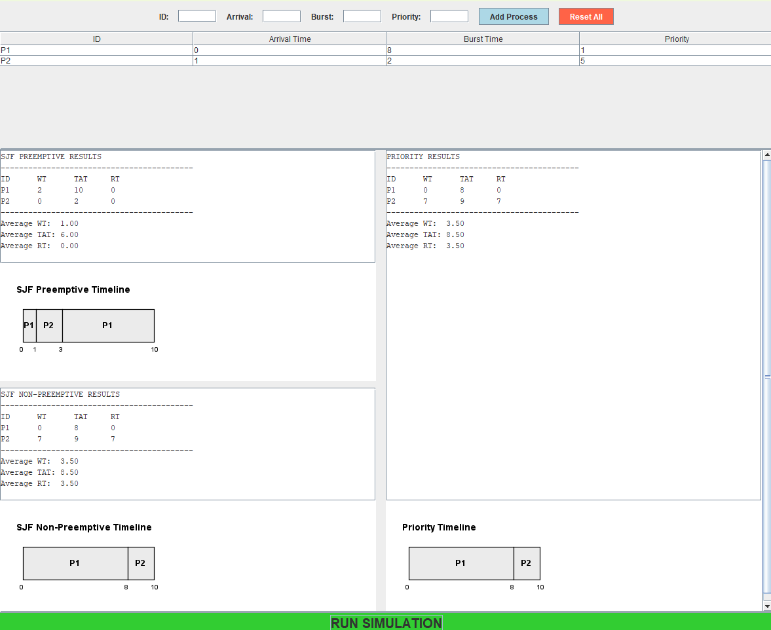

Scenario C: Fairness or Starvation-Sensitive Case
- Input Data:
  - P1: Arrival=0, Burst=10, Priority=10 (Long & Low Priority)
  - P2: Arrival=1, Burst=2, Priority=1
  - P3: Arrival=2, Burst=1, Priority=2
- Description
"This scenario demonstrates starvation risks. In SJF Preemptive, P1 suffers the most as it is constantly interrupted by shorter jobs. In Priority, P1 stays at the end of the queue because of its low priority. Interestingly, Non-Preemptive SJF provides a bit more fairness to P1 once it starts, as it cannot be interrupted by the arriving P2 and P3."
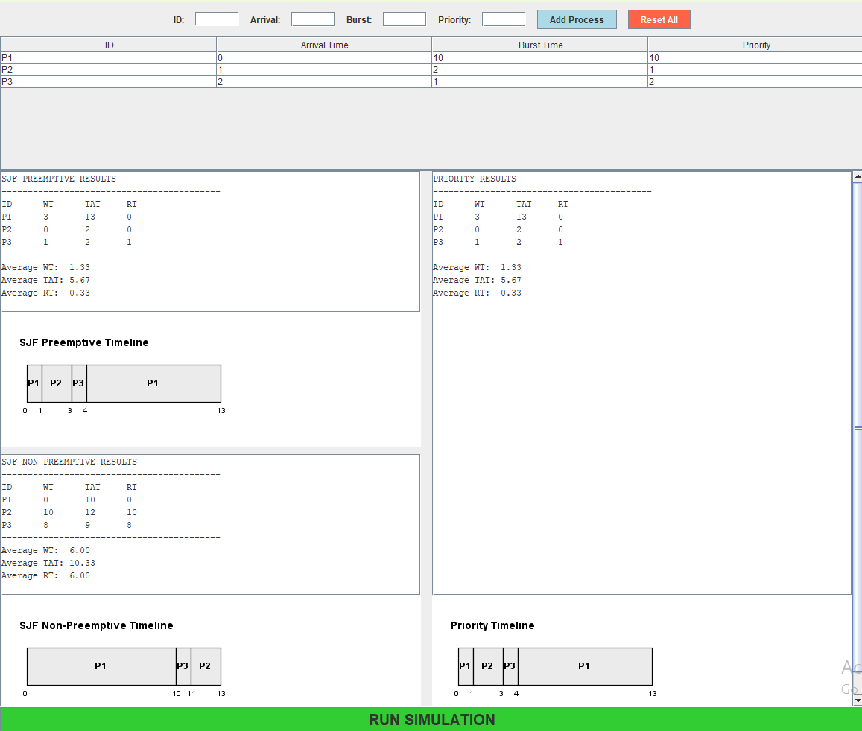
Scenario D: Validation Case
- Input Data:
  - Burst Time = -2
  - Priority = Empty
  - Arrival = "ABC"
  - ID ---> Duplicate IDs
- Description
"This case demonstrates the simulator’s input handling. The system correctly identifies and rejects invalid inputs like negative values, empty fields, and non-numeric data. This ensures the stability of the scheduling simulation and prevents logical errors in metric calculations."
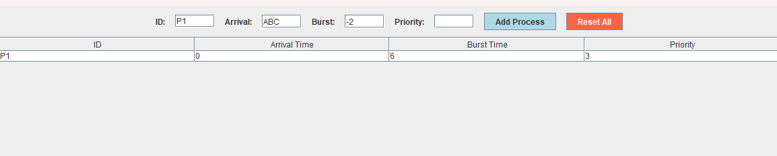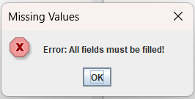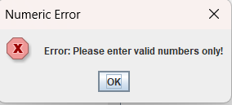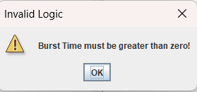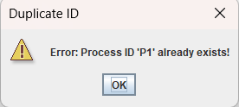

Section 3: Required Comparison Focus

* SJF Behavior with Short Job / Low Priority: SJF focuses exclusively on burst time, so it will execute a short job immediately to minimize waiting time, even if that job has the lowest priority in the system. This demonstrates that SJF prioritizes system efficiency over task importance.

* Priority Behavior with Long Job / High Priority: Priority scheduling will grant the CPU to a high-priority process regardless of its burst length. Even if the job is very long and slows down the entire system, the algorithm ensures it is served first because it is labeled as "urgent" by the system policy.

* SJF Impact on Average Metrics: SJF (especially the preemptive version) is mathematically designed to improve and minimize Average Waiting Time (AWT) and Average Turnaround Time (ATAT). By finishing short jobs quickly, it reduces the number of processes waiting in the queue.

* Priority Impact on Urgent Processes: Priority scheduling significantly improves the service quality and Response Time for urgent processes. It ensures that critical tasks do not have to wait for non-essential jobs, which is vital for time-sensitive or mission-critical applications.

* Unfair Delay Analysis: Both policies can cause unfair delays. SJF causes an unfair delay to long processes (Starvation) if short jobs keep arriving. Priority scheduling causes an unfair delay to low-priority processes, which may never execute if high-priority tasks continue to enter the system.

Section 4: Required Analysis Questions

- Which algorithm gave lower average waiting time?
  - In almost all tested workloads, SJF Preemptive (SRTF) provided the lowest average waiting time. This is because it reduces the overall queue length by finishing shorter tasks as quickly as possible.
- Which algorithm gave lower average turnaround time?
  - SJF Preemptive also resulted in the lower average turnaround time. Since turnaround time includes waiting time, the efficiency of SJF in minimizing wait times directly leads to faster overall completion for the majority of processes.
- Did SJF favor short jobs more strongly?
  - Yes, SJF favored short jobs more strongly than any other policy. It is designed specifically to select the process with the smallest burst time next, ensuring that short jobs do not stay in the system longer than necessary.
- Did Priority Scheduling favor urgent processes more strongly?
  - Yes, Priority Scheduling prioritized urgent processes regardless of their burst time or arrival. It ensured that tasks with higher importance (lower priority values) were granted CPU time immediately, fulfilling the system's policy requirements.
- Was any starvation or unfair delay observed?
  - Yes, starvation was observed in two forms: in SJF, long processes were delayed when short processes kept arriving; and in Priority, low-priority processes waited significantly longer when high-priority tasks occupied the CPU. These are classic examples of unfair delays inherent in these non-fairness-based algorithms.
- Which algorithm would you recommend for the tested workload, and why?
  - The recommendation depends on the system's goal. If the goal is maximum efficiency and minimum user wait time, SJF Preemptive is recommended. However, if the system handles critical tasks that must be completed regardless of their size, Priority Scheduling is the better choice to ensure mission-critical performance.
Section 5: Analysis of Unfair Delay (Fairness vs. Starvation)

- SJF (Preemptive and Non-Preemptive): Both versions can cause an unfair delay to long processes. If there is a constant stream of short-duration tasks, a long process may be delayed indefinitely, a condition known as Starvation. This happens because the algorithm only cares about minimizing average waiting time, not about the "age" or "fairness" of long-waiting tasks.

- Priority Scheduling: This policy causes a significant unfair delay to low-priority processes. Even if a process is very short or has been waiting for a long time, it will always be bypassed by any newly arriving high-priority process. This is a "policy-driven" unfairness where the system intentionally favors importance over arrival order.

- Comparison of Delay: While SJF is unfair to "long" jobs, Priority is unfair to "low-status" jobs. In our simulation, we observed that SJF Non-Preemptive is slightly less "unfair" than its preemptive counterpart once a process starts, as it guarantees that a long job—once it finally secures the CPU—will not be delayed further by preemption.

Section 6: Required Conclusion

- Which algorithm performed better on the selected datasets?
  - The performance depends on the evaluation criteria; however, SJF Preemptive performed better overall in terms of system-wide throughput and minimizing delays across our mixed datasets. Priority Scheduling performed better only when the dataset contained critical, time-sensitive tasks that required immediate execution regardless of their length.
- Which metric did each algorithm handle better?
  - SJF (Preemptive and Non-Preemptive): These algorithms handled Average Waiting Time and Average Turnaround Time much better than Priority scheduling.
  - Priority Scheduling: This algorithm handled Response Time for urgent tasks better, ensuring that important processes were serviced with the highest priority.
- The trade-off between Efficiency and Urgency:
  - The observed trade-off is that SJF maximizes system efficiency by reducing the total time jobs spend in the system, but it ignores the relative importance of tasks. Conversely, Priority Scheduling respects the urgency of specific tasks as defined by the user or system policy, but this often leads to lower overall efficiency and higher average waiting times for the general workload.
- Which algorithm appeared fairer in practice?
  - In practice, SJF Non-Preemptive appeared slightly fairer once a process started, as it prevented short jobs from repeatedly interrupting a long job once it secured the CPU. However, none of the tested algorithms are perfectly fair; Priority is inherently "unfair" to low-status jobs, and SJF is inherently "unfair" to long jobs, leading to potential starvation in both cases.

Section 7: Final Recommendation

- For General-Purpose Systems: We recommend SJF (Preemptive) for environments where the primary goal is to provide fast service to the maximum number of users and minimize the total waiting time.

- For Real-Time and Critical Systems: We recommend Priority Scheduling for systems where task importance is paramount (e.g., medical equipment, flight controls, or critical server tasks), as it guarantees that high-priority jobs take precedence regardless of their duration.

- For Simple Batch Systems: We recommend SJF (Non-Preemptive) when system resources are limited and the overhead of preemption needs to be avoided while still maintaining a reasonable level of efficiency.

